Nursery Home Learning project – Look at Me!
Week 6
This week we are going to revisit PSED (Personal, Social and Emotional Development
Some activities are the same as last week any new activities are in red

Here are a few suggestions for activities that relate to our topic for the next few weeks. Pick activities which you feel your child will most engage with and don’t feel you have to do all of them, they are here as a guide. You might find other things that work really well so go for it.
Remember play is the most effective way children learn at this stage
Daily tasks
Establishing a daily routine will help so here is a rough guide
Read the morning message from Miss Walter
Watch a video from Miss Walter then have a go at the task
Free play or pick an activity from the list below
Watch a story video
Upload something onto the homework page to show us what you have done

Maths Activities | English Activities
Counting and recognising numbers  Every day this week the homework prompt will be some activities for numbers 6-10  Play number games  This is a great website we often use at Handsworth. Select Early Years to get age-appropriate games for Nursery  https://www.topmarks.co.uk/  Play Dominoes  Can children match the correct number pattern?  Pick a domino tile and add the dots together. Can you find numbers 1-10?  This activity needs a bit of preparation!  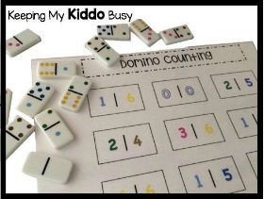  Draw a blank domino tile and ask children to copy it using bottle tops or small objects.  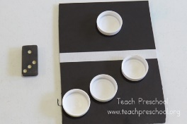  Numberblocks  Watch a programme on CBeebies, Use this guide here to give you ideas on what to do with your children whilst watching an episode.  Singing  Sing number songs to practice counting, reciting numbers in order, one more, one less. Click on the link below to get started  https://www.bbc.co.uk/teach/school-radio/nursery-rhymes-ten-in-the-bed/z7bnmfr  Here are some more great counting songs that we like singing in Nursery  https://www.youtube.com/watch?v=7D4K9oi7oBM  These activities are ones we would do in Nursery and worth repeating as many times as you can. | Phonics  Phase 1 is the first phase that will be taught to children at nursery. It is really important that children have a secure understanding of this phase before moving on. Developing these skills creates foundations for when children begin to learn their letters and sounds in later phases. During this phase, your child will begin to distinguish between different sounds within their environment and may begin to show an awareness of rhyme and alliteration.  We will start looking at the next phase after Half Term  Please read the Parents guide on the curriculum page for more information  Spoken segmenting and blending  This is a great way to emphasis the separate sounds in words. Blending and segmenting is a later skill that will be important when the time comes for your child to read and write.  Ask children to go and get their h-a-t or b-a-g have a go with simple 3 letter words but move on to bigger words if you can!  Phonics games  I spy names-Sit in a circle and play ‘I spy names’. “I spy someone’s name beginning with ‘s’. Who can it be”  The peron with the name beginning with ‘s’ stands up and all the children say his name. You can use toys if you don’t have lots of people in your house  Object sound game  Find objects around the house that begin with the same letter. Can you make up an alliterative sentence with all the objects?  Alphablocks  Watch a clip on CBeebies  Use this guide here to give you ideas on what to do with your children whilst watching an episode.  Some children may not be ready for these activities so it is ok to repeat any of the activities above.  - Give children lined paper and pens/pencils so they can ‘write’ a story of a letter or a list. It could be anything. Encourage them to tell you about their writing when they have finished.  (if you don’t have any lined paper we can give you some writing books from school. I will leave a selection of books in the school office)  - Give children a selection of pens/pencils for writing or drawing. Ask them to tell you what they have drawn and annotate it like it was a picture in a museum. If your child is into dinosaurs this is a great way to link their interest with writing!  Some other tools and resources to enable writing  - Blank diaries and calendars  - Telephone and address books  - Post-it notes  - Envelopes  - Postcards  - Invitations  - Chalk -can be used inside on a blackboard or outside on paths etc  - Sticks and twigs with earth/mud  - Clipboards and paper  - Pens/pencils/crayons/chalk  - Stampers with ink pads  - Paint brushes and paint or water  Read with your children daily.  Let them be in charge of which books they would like to read. For online books visit Oxford Owl for free eBooks that link to your child’s reading stage if they are ready for this. These books also have audio and so your child can listen to the story being read whilst following along with the words. You can create a free account by clicking on the link below. You can also complete the linked play activities for each book afterwards.  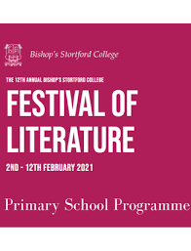 Take part in some of the activities at the Festival of Literature. See the school website for more information
Physical development  Play outside in the garden/go to the park or forest  Pick a cosmic kids yoga story to try  Cutting skills – give children different types of paper eg, card, tissue paper to pratce cutting  Make playdough, click here for a recipe  Have a go at these playdough gym activities  Cook dinner!  We like cooking recipes from CBeebies My world kitchen  https://www.bbc.co.uk/cbeebies/shows/my-world-kitchen | Art  Draw or paint a picture of your house or flat. Maybe you could make a model of your house?  Look at the shapes of the doors, windows and roof. What colours will you use?  Who lives in your house with you?  What rooms do you have in your house?  Draw a map of your route to Nursery or to your friend’s house. You could even make a map of an imaginary place.  Have a look at famous paintings. Talk about how they make you feel?  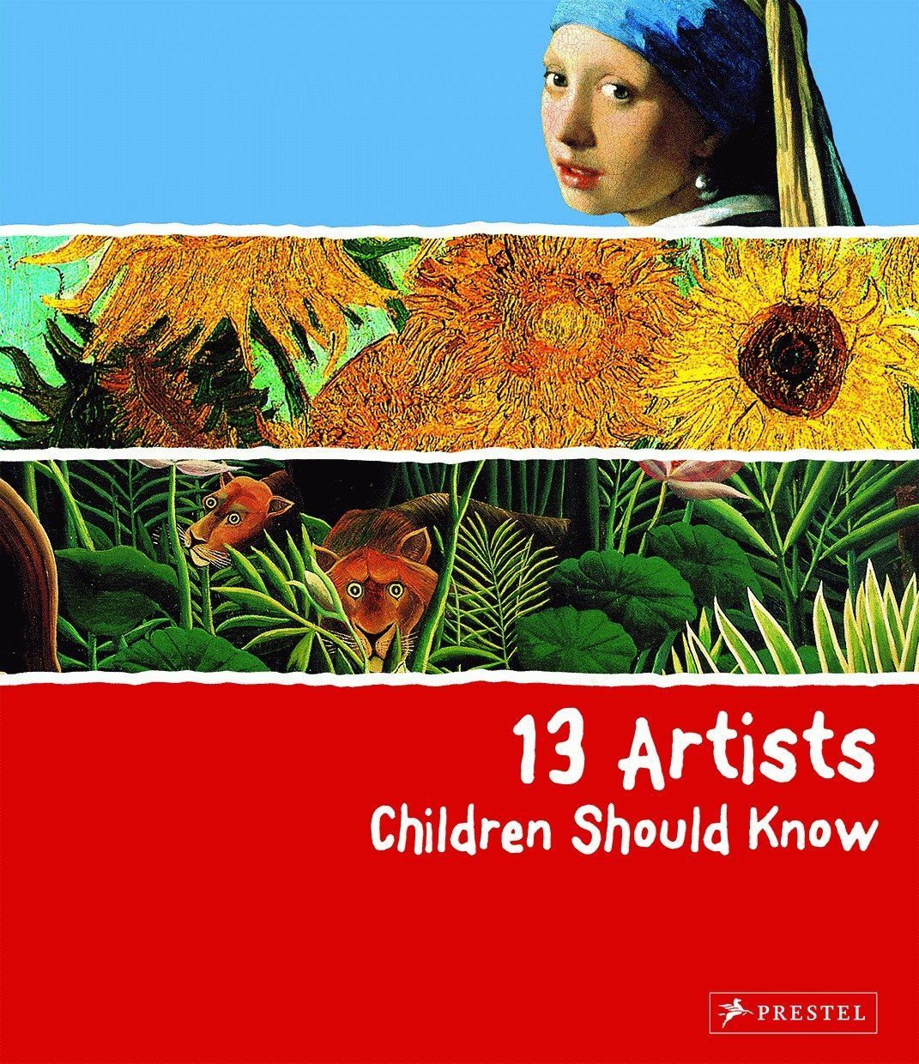 This is a book we have in school.  There are lots of books in the series, but you could also look at the following art gallery collections  https://www.nationalgallery.org.uk/  https://www.wallacecollection.org/  https://www.tate.org.uk/
Science/Understanding the world  Everyday activities that could include predictions could include cooking, gardening, having a bath or washing up  Science experiments  Here are a few websites that have great ideas for simple Science experiments.  - https://www.firstdiscoverers.co.uk/early-years-science-activities-eyfs/  - https://www.science-sparks.com/early-years-science-themed-activities/  - https://www.stem.org.uk/resources/community/resource/258613/early-yearsreception-science-homeworks  Watch the Science experiment videos Miss Walter did this week  Find out about the place you live by going for a walk around. What different places can you see? If there are lots of houses, do they all look the same?  Look out for wildlife when you go for your daily walk. Look at the rspb website to identify any birds you might see https://www.rspb.org.uk/ | Website  There will be a daily homework prompt on the website so you can upload pictures or videos of anything you do as well as daily videos and activities  Look in Archive/Articles 2019/20 for some great activities from Mrs Giacuzzo and Mrs Lewis from last term
Additional resources
There are some great websites to look at in the Home Learning section of the Nursery webpage

Keep Early Years Unique
online activities or suggestions of things to do that don't require the use of tech
https://www.keyu.co.uk/new-learning-at-home-together/

National Geographic Kids
https://www.natgeokids.com/uk/
Activities and quizzes for younger kids.

Nature Detectives
https://naturedetectives.woodlandtrust.org.uk/naturedetectives/
A lot of these can be done in a garden, or if you can get to a remote forest location!

