Learning Project Summer 2 Ducks/ Minibeasts
We will continue to look after our ducks at school this week.
Everyday we will post pictures and videos about them.
If you have exhausted the possibilities with ‘Ducks’ at home, here is a plan all about creepy crawlies! Get outside and go bug hunting!
Weekly Maths Tasks  (Length, height and weight) | Weekly Reading Tasks (Aim to do 1 per day)
- Watch a Numberblocks clip each day at: BBC or CBeebies. Use this guide here to give you ideas on what to do with your children whilst watching an episode.  - Practice writing numbers – how many can you write? Can you write a 100 square?  - Use this tens frame to practise making different amounts. Or, your child can practice making amounts to 10 using different objects from the garden e.g. leaves.  - Your child can compare objects from around the house or outside. Order the objects by length, height and weight  - Can your child find things inside the house that are taller/shorter than them or a favourite toy?  - What is the heaviest/lightest thing they can find to weigh?  - When you go out for a walk see if you can measure how tall a tree is (here is an easy way to do it!)  - Make something yummy to eat and talk about the measurements we use to weight things. How much does an egg weigh? Can you find things that weigh the same as an egg?  - Make this easy cake recipe just by weighing the eggs  - Ask your child to use Lego, blocks or cardboard boxes to build a tower that is the same height as them, taller than them and shorter than them.  - - Play the online game Let’s Compare. Following this, your child can sing the song Short or Tall.  - Ch cut out six eggs and blutak onto a nest. Draw a duck on the back. As each egg hatches we will turn the duck round to practice number bonds to six. | - Read with your children daily. Visit Oxford Owl for free eBooks that link to your child’s book band. You can create a free account. Complete the linked Play activities for each book.  - Ask your child to read the Reception key words and/or the list of tricky words (uploaded to the website a few weeks ago) CHALLENGE: Ask your child to find these tricky words in the stories you are reading.  - Enjoy reading non fiction books together. There are lots online: My first book of garden bugs, The bug book, Big Buzz  there are loads to choose from!  - Using the stories as a starting point, ask your child to make up their own story about creepy crawlies. It could use the same characters or settings as one of the stories you have shared together  - Ask your child to use pictures from a familiar story book to make up their own story or to retell their favourite story.

Weekly Phonics Tasks (Aim to do 1 per day) | Weekly Writing Tasks (Aim to do 1 per day)
- Daily phonics – We will post daily phonics input on our class pages. Have a go at set 3!  - Ask your child to find different things around the house/garden. Can they segment each word into sounds i.e. c-u-p (cup), b-e-d (bed) t-ea (tea), ch-air (chair)? If they are able, they could write these too.  - Make a list of words that all begin with ‘d’ make a list of words about ducks  - Play the Word Machine - Ask your child to read each word carefully. Match the correct word to the picture. If you get it right, you will hear a clap. Click ‘Next’ and have a go at another word (this game needs flash player enabled!)  - Write the letters of the alphabet on a piece of paper. Use some books you might have, or with an adult have a look at pictures of ducks from around the world. Can you find a duck for every letter of the alphabet? | - Use this animated letter formation tool to help your child practise letter formation. You can select those they find most challenging  - Learn about the parts of an insect’s body. Can you label a picture of an insect?  - ​Talk about the lifecycle of a duck. Can you make a poster about it?  - Read The Very Hungry Caterpillar. Can you make a list of all the foods that the caterpillar ate?  - Use your garden or go to the lake, draw and list the bugs you find there.  - Make a book about insects. Give each page a title. Draw a labelled diagram and write a sentence about each insect.
Learning Project – Activities to complete throughout the week

The project this week aims to provide opportunities for your child to learn more about the lifecycle of a duck and the habitats ducks live in

Watch these great creepy crawly videos

Build a bug hotel
Head down to the forest and forage for materials to make a bug hotel. The RSPB have a great guide on how to build one. Keep an eye on the different insects that come to visit. Can you keep an observation diary?
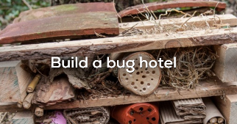

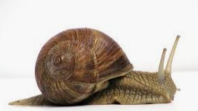
Rainy days
After a rain shower, go outside and see how many snails you can find. Make a collection in a bucket to look at. You can use this powerpoint to learn all about slugs and snails.
Learn about the collage ‘The Snail’ by Matisee. Here is a Tate art lesson inspired by the Snail.

Ladybird Rocks
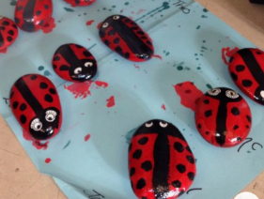
Collect some large rocks and stones and paint them to look like your favourite insects. Ladybirds are great because you can learn about symmetry and doubling. Once you have made your insects, they are great props for small world play. Can you make a story with your insects? Perhaps you could film it?

Worms
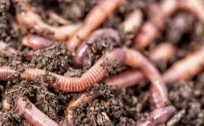
I know it’s quite gross but honestly, going digging for worms is such a good learning day! You can learn about worms here. And from this great book about worms. Use this playdough recipe to make your own worms. Can you order them by length?

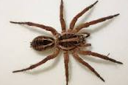
Spiders
AAh! Spider! Have a look under rocks and in cobwebs for spiders.You can learn more about spiders with this video. Here is some spider craft you can make from old recycling. Practise counting to 8 with this Spider maths video
Additional learning resources parents may wish to engage with
Waltham Forest have collected plenty of useful resources to keep you and your children entertained during this time.
Thanks to #TheLearningProjects who let us use their learning materials for you at home

