Nursery Home Learning project – Look at Me!
Week 4
This week we are going to focus on Understanding of the World (this includes People and Communities, The World and Technology)
Some activities are the same as last week any new activities are in red

Here are a few suggestions for activities that relate to our topic for the next few weeks. Pick activities which you feel your child will most engage with and don’t feel you have to do all of them, they are here as a guide. You might find other things that work really well so go for it.
Remember play is the most effective way children learn at this stage

Daily tasks
Establishing a daily routine will help so here is a rough guide
Read the morning message from Miss Walter
Watch a video from Miss Walter then have a go at the task
Free play or pick an activity from the list below
Watch a story video
Upload something onto the homework page to show us what you have done

Maths Activities | English Activities
Number formation  Practise writing numbers by making a number line from 1-10 (or 20)  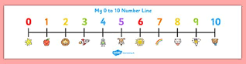  Counting and recognising numbers  Do some baking this week!  Play number games  This is a great website we often use at Handsworth. Select Early Years to get age-appropriate games for Nursery  https://www.topmarks.co.uk/  Here are some more counting and number recognition games  Play simple board games that use a dice  Roll a dice and get the same number of objects as the number shown. The winner is the person with the most objects after 5 goes (or however many goes you decide!)  Play Dominoes Click here to print some Dominoes  Draw a number track and write numbers within each segment. 1-20 is ideal. Choose some counters and get a dice. Put your counters at the start and roll the dice to start. Then move your counters to see who will win.  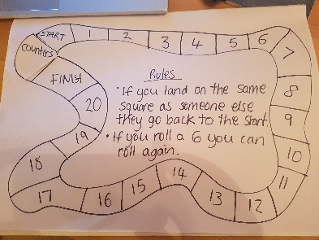  Go on a number hunt where you live. Where can you find numbers? Have a look inside your house and outside  Numberblocks  Watch a programme on CBeebies, Use this guide here to give you ideas on what to do with your children whilst watching an episode.  Singing  Sing number songs to practice counting, reciting numbers in order, one more, one less. Click on the link below to get started  https://www.bbc.co.uk/teach/school-radio/nursery-rhymes-ten-in-the-bed/z7bnmfr  Here are some more great counting songs that we like singing in Nursery  https://www.youtube.com/watch?v=7D4K9oi7oBM  These activities are ones we would do in Nursery and worth repeating as many times as you can. | Phonics  Phase 1 is the first phase that will be taught to children at nursery. It is really important that children have a secure understanding of this phase before moving on. Developing these skills creates foundations for when children begin to learn their letters and sounds in later phases. During this phase, your child will begin to distinguish between different sounds within their environment and may begin to show an awareness of rhyme and alliteration.  We will start looking at the next phase after Half Term  Please read the Parents guide on the curriculum page for more information  Here are some Phase 1 games to try  Watch the phonics games videos on the website from Week beginning 10th January  Alphablocks  Watch a clip on CBeebies  Use this guide here to give you ideas on what to do with your children whilst watching an episode.  Letter Formation- Can you trace/write the letters in your name? Do you know the sound that each letter makes? Don’t worry about pencil grip at this stage it is a work in progress!  Watch the writing videos from Miss Walter (week beginning 10th January)  Writing  Some children may not be ready for these activities so it is ok to repeat any of the activities above.  Talk about the things people forget and need reminding about. Include shopping lists, reminders for special occasions such as Birthdays, regular jobs such as taking the rubbish out. Make lists and write reminders this week. If there are any Birthdays coming up in the family encourage children to write a card (this is a great opportunity to practise writing their name)  Writing patterns  Draw patterns on a piece of paper and encourage children to ‘write’ on top of your marks with paint or felt pens.  Give children a piece of paper and some pens or pencils. Ask questions about the marks they make and label drawings or write out what they say in your own writing.  This helps children see there is a purpose to the marks they make and that we think their writing is important  Read and Rhyme! Read a book with rhyming words in it. Chose any that you already have at home or you could try this link for Frog on a Log Favourite books can be repeated. Hearing the patterns of language in a story will support your child’s language development. Particularly look out for any rhyming words! Maybe you could start a word chain and see how many rhyming words you can think of (they don’t have to be real words!)  Read with your children daily.  Let them be in charge of which books they would like to read. For online books visit Oxford Owl for free eBooks that link to your child’s reading stage if they are ready for this. These books also have audio and so your child can listen to the story being read whilst following along with the words. You can create a free account by clicking on the link below. You can also complete the linked play activities for each book afterwards.  Draw a picture of what you did today.  Write down what your child tells you about their picture. Read the words back to them pointing to each word as you read. This will reinforce the idea that in English we read from left to right  People in your family  Look at family photos and talk about where you were when the photo was taken and what you were doing.  We ran out of time to show staff photos last week so they will appear this week!  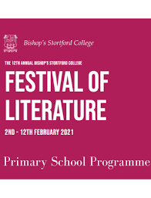 Take part in some of the activities at the Festival of Literature. See the school website for more information
Physical development  Play outside in the garden/go to the park or forest  Pick a cosmic kids yoga story to try  Cutting skills – Click here for a simple house picture to colour and cut out  Make playdough, click here for a recipe  Try this website that we look at in school  https://5-a-day.tv/  Login using these details and pick any workout (it might be best to choose a Nursery/Reception one initially!)  Username - HPSE9HA​  Password - u7xtlUM3 | Art  Draw or paint a picture of your house or flat. Maybe you could make a model of your house?  Look at the shapes of the doors, windows and roof. What colours will you use?  Who lives in your house with you?  What rooms do you have in your house?  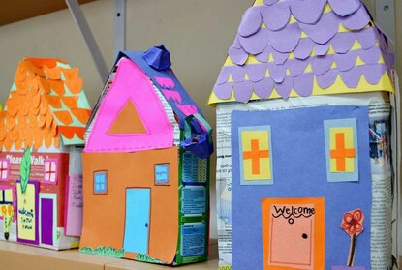  Draw a map of your route to Nursery or to your friend’s house. You could even make a map of an imaginary place.
Science/Understanding the world  Everyday activities that could include predictions could include cooking, gardening, having a bath or washing up  Science experiments  Here are a few websites that have great ideas for simple Science experiments.  - https://www.firstdiscoverers.co.uk/early-years-science-activities-eyfs/  - https://www.science-sparks.com/early-years-science-themed-activities/  - https://www.stem.org.uk/resources/community/resource/258613/early-yearsreception-science-homeworks  Watch the Science experiment videos Miss Walter did this week  Find out about the place you live by going for a walk around. What different places can you see? If there are lots of houses, do they all look the same?  Look out for wildlife when you go for your daily walk. Look at the rspb website to identify any birds you might see https://www.rspb.org.uk/ | Website  There will be a daily homework prompt on the website so you can upload pictures or videos of anything you do as well as daily videos and activities  Look in Archive/Articles 2019/20 for some great activities from Mrs Giacuzzo and Mrs Lewis from last term
Additional resources
There are some great websites to look at in the Home Learning section of the Nursery webpage

Keep Early Years Unique
online activities or suggestions of things to do that don't require the use of tech
https://www.keyu.co.uk/new-learning-at-home-together/

National Geographic Kids
https://www.natgeokids.com/uk/
Activities and quizzes for younger kids.

Nature Detectives
https://naturedetectives.woodlandtrust.org.uk/naturedetectives/
A lot of these can be done in a garden, or if you can get to a remote forest location!

