Nursery Home Learning project
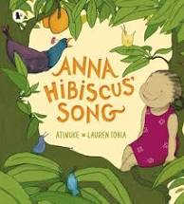
Anna Hibiscus Song
Activities are based on the above book by Atinuke
Here are a few suggestions for activities that relate to our topic for the next few weeks. Pick activities which you feel your child will most engage with and don’t feel you have to do all of them, they are here as a guide. You might find other things that work really well so go for it.
Remember play is the most effective way children learn at this stage

Daily tasks
Establishing a daily routine will help so here is a rough guide
Focused Maths or English task
Free play or pick an activity from the list below
Snack/lunch (a great time to practise Fine motor skills such as chopping!)
Watch a story video ( the videos from Lockdown are all available on the Nursery Home page)
Email Miss Walter with a picture of something you have done each day

Maths Activities | English Activities
Number formation  Click here for the rhymes we will use to help Number formation Don’t worry about pencil grip at this stage as it is a work in progress!  Number  Scan the QR code below to watch a Maths lesson. There are 5 sessions with accompanying pdf’s  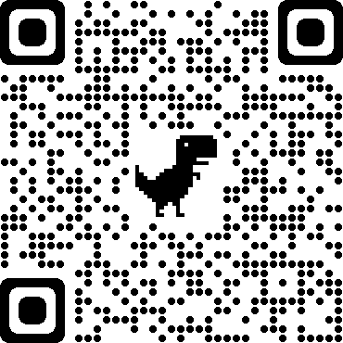  Addition  Click here to download Numicon shapes. These can be cut out and then put together to make a bigger number  Numicon.pdf  Click on the link below for some more ideas about addition  https://www.teachstarter.com/gb/blog/10-easy-simple-addition-activities-kids-gb/  Numberblocks  Watch a programme on CBeebies, Use this guide here to give you ideas on what to do with your children whilst watching an episode.  Singing  Sing number songs to practice counting, reciting numbers in order, one more, one less. Click on the link below to get started  https://www.youtube.com/watch?v=V_lgJgBbqWE  Make a timetable of your day- children like to know what is happening and when. A timetable is also a great way to introduce the concept of time  Practise number facts to 10  This is a great game (the website has lots of games about addition or subtraction)  https://www.topmarks.co.uk/addition/addition-to-10  This is a board game to print out, or you could make your own version  https://www.sparklebox.co.uk/previews/7201-7225/sb7212-addition-to-10-board-game.html  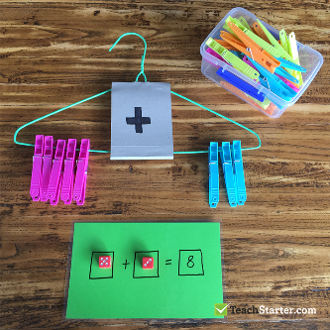 a game to play using dice and clothes pegs. Roll the dice to get the first set of pegs and again for the second then add all the pegs together | Phonics  Here are some Phase 2 games to try. We have only just started learning letter sounds, many games offer the option of selecting or editing the sounds used in the game so it can be made easier or harder to play  Alphablocks  Watch a clip on CBeebies  Use this guide here to give you ideas on what to do with your children whilst watching an episode.  Letter Formation- Can you trace/write the letters in your name? Do you know the sound that each letter makes? Don’t worry about pencil grip at this stage, it is a work in progress!  Read and Rhyme! Read a book with rhyming words in it. Chose any that you already have at home or you could try this link for Frog on a Log Favourite books can be repeated. Hearing the patterns of language in a story will support your child’s language development. Particularly look out for any rhyming words. Maybe you could start a word chain and see how many rhyming words you can think of (they don’t have to be real words!)  Read with your children daily.  Let them be in charge of which books they would like to read. For online books visit Oxford Owl for free eBooks that link to your child’s reading stage if they are ready for this. These books also have audio and so your child can listen to the story being read whilst following along with the words. You can create a free account by clicking on the link below. You can also complete the linked play activities for each book afterwards.  https://www.oxfordowl.co.uk/please-log-in?open_loginbox=true  Draw a picture of what you did today.  Write down what your child tells you about their picture. Read the words back to them pointing to each word as you read. This will reinforce the idea that in English we read from left to right  Writing  Print out pictures of favourite story characters and encourage your child to either write about the character or dictate a story to you that you then read back to them. This writing may look less like recognisable letters and more like random marks but it is important to acknowledge it as ‘writing’  Take photos of activities you do and write a caption to describe what is happening in the photo  Read poems about being outdoors ‘Out and about’ by Shirley Hughes is a great place to start
Physical development  Gross Motor (whole body)  Play outside in the garden/go to the park or forest  Pick a cosmic kids yoga story to try  Fine Motor( small hand/wrist movements)  - Building a tower of approximately nine small blocks.  - Copying block designs of up to 9 blocks.  - Designing own Duplo/Lego models  - Tracing on thick lines  - Copying a simple shape such as a triangle or circle  - Colouring a picture  - Writing letters/numbers  - Writing their name  - Threading a sequence of small beads onto string.  - Cutting roughly around pictures/cutting along a line continuously  - Dressing independently including large buttons, socks and shoes (excluding shoelaces, small buttons and initiating zip on a jacket).  Make playdough, click here for a recipe  - Watch a South African Gumboot dance or have a go at other dances from Africa https://video.link/w/ALf1c | Art  - Draw/paint a picture of your family or the people who live with you  - Listen to or play tradition African instruments such as a djembe drum. Listen to music from some of the countries in Africa  (artists such as Baaba Maal, and Miriam Makeba are great places to start)  - Look at African patterns such as those on Nbele houses and recreate  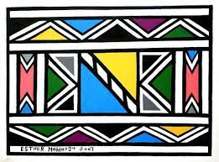
Topic activities

- Look at different types of homes where you live.
- Talk about homes that have a garden to play in, like Anna does and homes that don’t.
- Find Africa on a map or globe. Watch videos that show some of the different countries and environments such as Planet Earth Are they the same or different to where you live?
- Find out about the animals that live in different parts of Africa. Maybe create them in art/read stories about them/make a small world environment for them

Personal, Social and Emotional activities
Click here to learn our new breath Snake breath
Read The Colour Monster book by Ana Lenas or listen to Miss Walter reading the story on the Nursery website (6.10.20) and spend time talking about the feelings described in the story. It’s a great book to use regularly to help discuss emotions and what helps us when we feel sad etc

