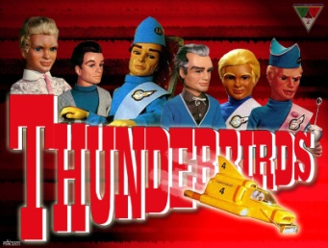
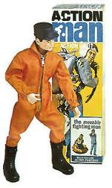
Toys From The Past

Ask someone at home what their favourite toy or toys were when they were your age. Try to ask parents and grandparents so you have an idea of how toys have changed over time.
Name of person….……………………..
Age (If they don’t mind sharing this!)…………
Name of toy……………………………………………
What was it?
................................................................................................................................................................................ ………………..
Can you still buy it today? ....................................
What did they like about this toy?
..........................................................................................................................................................................................................
Do they still have this toy? …………………
What other toys were very popular at the time?
.......................................................................................................................................................................................................
If they still have it, see if you can take a picture and bring it in or try and find some pictures from the internet for the rest of the class to look at.
Please return to school by Thursday 15th January
Please can children also bring in 1 small toy on Thursday – this needs to have a value of less than £5, be labelled and one which they don’t mind sharing.

