**Physical Development**

**Fine motor skills-** developing pencil control and grip and scissor skills.

Independent dressing.

**Gross motor skills-**

**PE-** Gymnastics - Learning to use equipment.

Dance – Moving and responding to music.

Moving and using space safely.

Changing for PE

**Maths**

Counting up to 20

Recognising and ordering numbers

Matching numerals to quantities

Number formation

Recording numbers

Addition

Partitioning

2 D Shapes

Position

Repeating patterns

Solving problems

Sorting

**Literacy**

Reading and writing activities based on the books **So Much by Trish Cooke** and **We’re going on a Bear Hunt by Michael Rosen.**

Phonics - Learning the sounds of letters in the alphabet and segmenting and blending to make simple words.

Learning to read key words.

Writing and recognising own name.

Letter formation.

Reading familiar stories and looking at non-fiction books.

Writing weekend news

**Personal Social and Emotional Development**

Getting to know our class and school.

Rules in Reception and school – The Golden Rules.

Circle Time-Self -Esteem – ‘I am special because…’

P4C (Philosophy for Children) – talking and discussing interesting problems.

Special Books – children sharing and celebrating their achievements.

**Communication and Language**

Weekend news- talking and sharing with the class.

Word wall - exploring new and interesting words.

Helicopter stories – creating and performing stories.

Story time.

Rhyme time.

Role play – Café.

Talking and listening to each other.

Show and tell.

Discussions based on topic.

Reception – Curriculum Overview Autumn Term 1 2016

**Magnificent Me**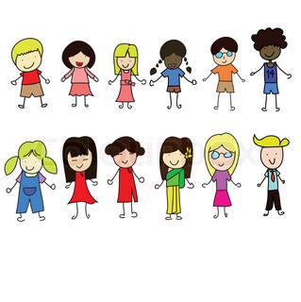

**Expressive Art**

Exploring and combining a variety of materials to create different effects.

Collage.

Painting.

Printing.

Creating pictures of ourselves and our families.

Music – Music Express - ‘ Our Senses’ - exploring and experimenting with sounds and words.

Role play area – café.

**Understanding the World**

Our Local environment - looking at where we live-walk around the community.

Investigating artefacts from the past.

Making and looking at maps.

Planting – planting bulbs and seeds.

Science – Sound and Listening.

Our body – labelling body parts and learning about our senses.

Talking about our families - similarities and differences.

ICT- ‘Switched on ICT’- Learning how to use different pieces of equipment.

RE- Learning about world festivals.