Year 1 Homework  2 February 2015  Reading  Please sign your child’s home school diary when your child’s finished reading a book. Make sure reading books are in the book bags.  Your child needs to read at least 15min every day. Give them time to read. Reading is a skill and it takes time to develop. Allow them to reread the same books. Rereading the words over and over helps them build fluency. Over time you’ll see that your child stops less often to decode words. If your child is stuck on a word point to the first letter and encourage him to sound it out. Take turns reading. Once you’ve finished a page ask your child to read the page too. After this you can ask questions about the page/book. Eg. What was the story about? Who is the main character? What kind of character was he? A good or bad person? How do we know this? What clues can we get from the story? Where did the story take place? What clues do we see in the book?  Change school library books:  Monday Miss Nadeem  Tuesday Miss Jordaan | Maths  This week we’ve been learning about:  Subtraction  Here are the steps to follow to play games online  Google  Hit the button  Number bonds  Subtraction within 20  Subtraction within 100  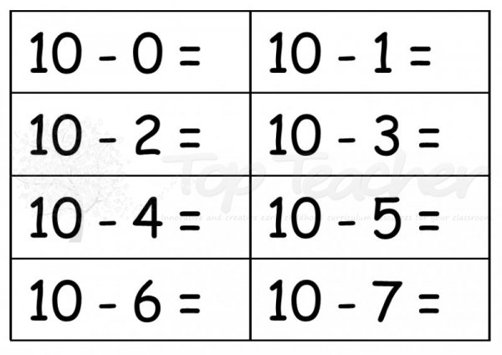  See how quickly you work out these answers mentally…or use your fingers.  Don’t let the villain scare you….try to work out these answers.
Phonics  Please encourage your child to read these words.  If they are not yet able to read the words they can sound them out. Remember to sound out and then blend eg.  air  air  fair  unfair  hair  despair  stairs  chair  funfair  pair  dairy  millionaire  Can you spot the new words on the list? | Spelling Week commencing 9th February 2015  Children need to learn how to spell all of these words.  They will be tested on the 13th February 2015  Look at word and copy Cover word and write Ask adult to say word and then write  house  laugh  first  mouse  good  little  night  people  Choose 2 words from the list and write down a sentence of your own. Start your sentence with the word If.  These spellings are also stuck in your spelling books
